Tutorial create key-pair on SAS Alibaba
- Generate/import key pair
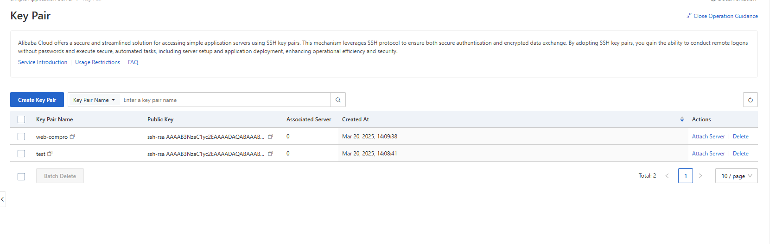
- Attach Key Pair to specific server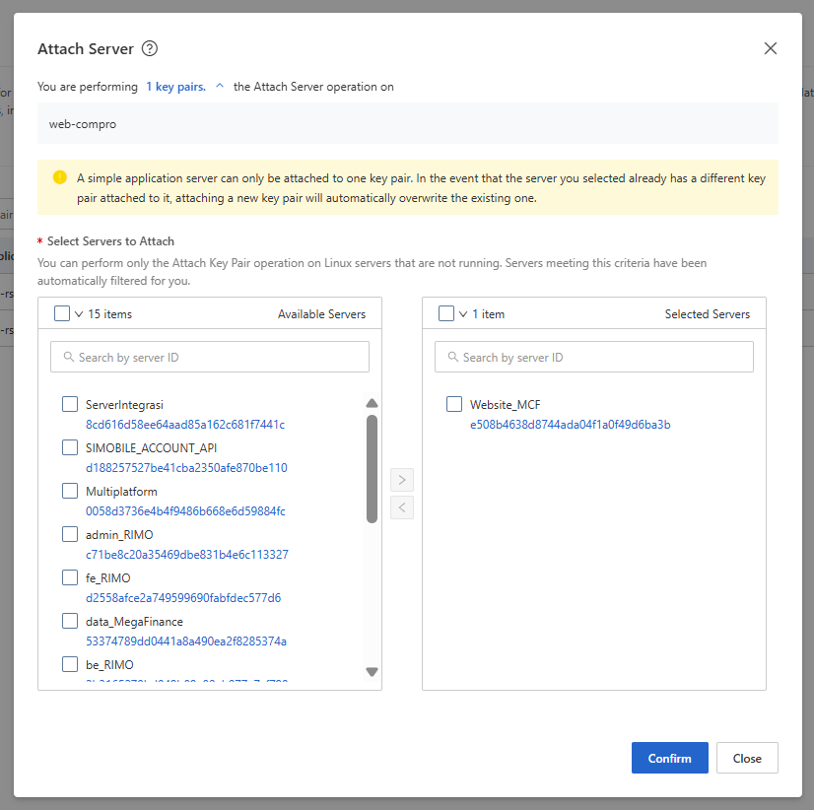
- Restart server after attach key-pair
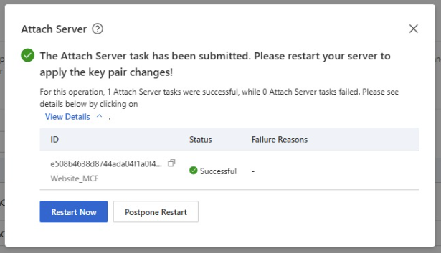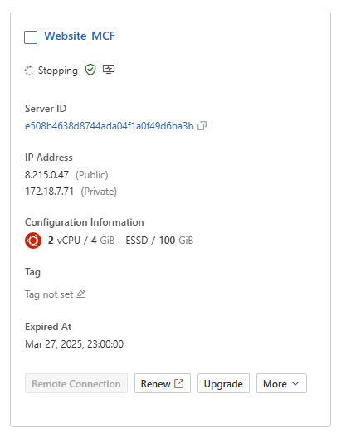
- Configure Putty for login using private key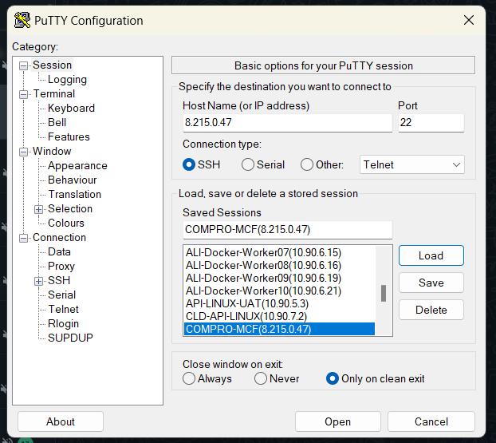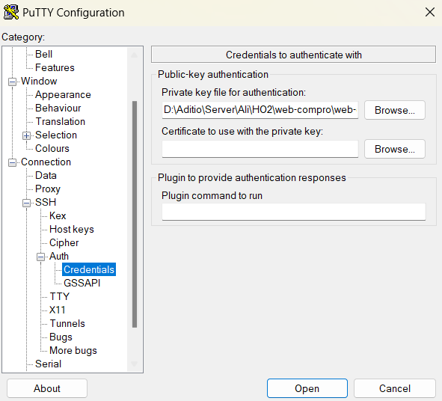
5. Test login using root account and password for testing after attach key-pair